Practise Questions
Question 1 [20]
- List the activities included in Henri Fayol’s concept of management and discuss how useful this approach is to describing the management process for a software development project [7]
- Explain Henri Fayol’s how principles of unity of command and unity of direction contribute to effective management. [6]
- Describe Mintzberg’s definitions of managerial roles. In addition, explain how these are applicable to project managers [7]
Question 2 [20]
Activity | Time | Precedents
A | 7 | -
B | 43 | A
C | 12 | -
D | 4 | I, M
E | 8 | -
F | 34 | B
G | 14 | F, L
I | 8 | G, K
J | 42 | A
K | 8 | J, L
L | 35 | C, E
M | 4 | G, K
N | 6 | I
O | 4 | D, N

- Construct an activity-on-arrow (AOA) network diagram given the table above. [6]
F
B
AA
O
N
J
I
G
C
D
L
E
M
K

- Calculate the early start and late start values for each node on the diagram. [6]
EL = ES + Activity time
LS = LF – Activity time

- Calculate the Total Float, Free Float and Independent Float for two activities that are NOT on the critical path. [6]
Question 3 [20]
Given the following table and network diagram:
Activity | Optimistic Time | Most Likely Time | Pessimistic Time
A | 1 | 3 | 4.5
B | 4 | 6 | 10
C | 2 | 7 | 9
D | 2 | 6 | 10
E | 5 | 8 | 11
F | 1 | 7 | 7
G | 2 | 5 | 8
H | 3 | 6 | 9
I | 5 | 7 | 9
J | 13 | 15 | 19

1
2
3
4
5
6
7
A

B

C

D

E

G

F

I

H

J

- Determine the most likely finish time (µ) for this PERT network. [6]
- Which is the critical path through the network? [2]
- What is the likelihood (probability) of finishing at time 30? [8]
T = (a+ 4m + b)/6
= (1 + 4(3) + 4.5)/6
= 2.92
= 3
By what time is there a 95% certainty of finishing the project? [4]
Question 4 [20]
Assumptions: A Five Day Working Week (Monday to Friday), Work for 8 Hours per Day.
Given a project described as follows (Precedence table + Resource sheet + Gantt chart):
 | Activity | Duration | Predecessors | Resources
1 | Start | 0
2 | System Design | 12 | 1
3 | Define work process | 3 | 1 | Project Manager
4 | Identify required information and resources | 2 | 3 | Project Manager
5 | Design software system to support work process | 5 | 4
6 | Basic software | 3 | 4 | Business Analyst, Developer, User
7 | Data access required | 1 | 6 | Business Analyst, Developer, User
8 | Vendor software required | 1 | 7 | Business Analyst, Developer, User
9 | Identify required hardware components | 2 | 8,5 | Business Analyst
10 | System Design Milestone | 0 | 9
11 | Hardware and Software Acquisition | 21 | 2
12 | Obtain quotations from hardware vendors | 2 | 10 | Buyer
13 | Obtain quotations from software vendors | 19
14 | Identify potential software products | 4 | 10,12
15 | Obtain test copies for user to examine | 10 | 14
16 | User comparison and approval | 5 | 15
17 | Hardware and Software Acquisition Milestone | 0 | 12,16,13
18 | Installation | 11 | 11
19 | Order components | 3 | 17
20 | Test components for technical functionality | 2 | 19
21 | Assemble system | 1 | 20
22 | Train user on software | 2 | 21
23 | User Test of system | 3 | 22
24 | Installation Milestone | 0 | 23,18

Resource | Cost/Hour
Project Manager | R 100.00/h
User | R 60.00/h
Business Analyst | R 50.00/h
Developer | R 40.00/h
Buyer | R 25.00/h
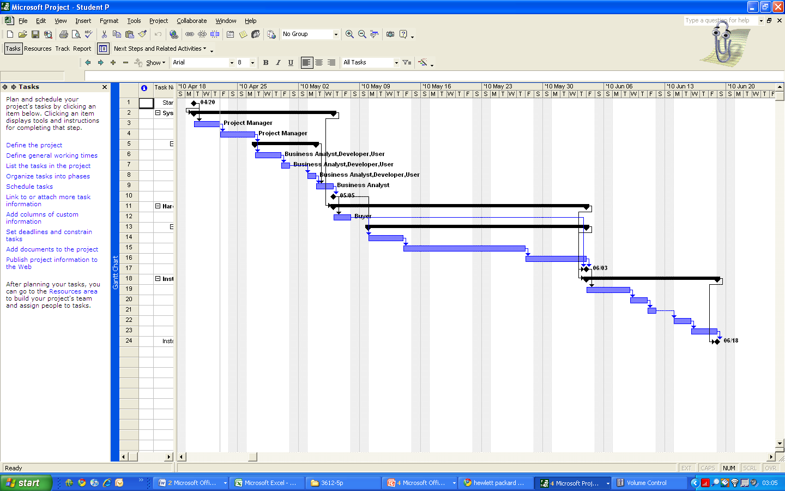
- How much money is earned by the Project Manager during the first week of the project?
- How much money is required to run this project for the first 10 days? [8]
- How much money us required for the first three weeks of the project? [8]

Standardized Normal Distribution Table

22
Z | 0.00 | 0.01 | 0.02 | 0.03 | 0.04 | 0.05 | 0.06 | 0.07 | 0.08 | 0.09
0.0 | 0.0000 | 0.0040 | 0.0080 | 0.0120 | 0.0160 | 0.0199 | 0.0239 | 0.0279 | 0.0319 | 0.0359
0.1 | 0.0398 | 0.0438 | 0.0478 | 0.0517 | 0.0557 | 0.0596 | 0.0636 | 0.0675 | 0.0714 | 0.0753
0.2 | 0.0793 | 0.0832 | 0.0871 | 0.0910 | 0.0948 | 0.0987 | 0.1026 | 0.1064 | 0.1103 | 0.1141
0.3 | 0.1179 | 0.1217 | 0.1255 | 0.1293 | 0.1331 | 0.1368 | 0.1406 | 0.1443 | 0.1480 | 0.1517
0.4 | 0.1554 | 0.1591 | 0.1628 | 0.1664 | 0.1700 | 0.1736 | 0.1772 | 0.1808 | 0.1844 | 0.1879
0.5 | 0.1915 | 0.1950 | 0.1985 | 0.2019 | 0.2054 | 0.2088 | 0.2123 | 0.2157 | 0.2190 | 0.2224
0.6 | 0.2257 | 0.2291 | 0.2324 | 0.2357 | 0.2389 | 0.2422 | 0.2454 | 0.2486 | 0.2517 | 0.2549
0.7 | 0.2580 | 0.2611 | 0.2642 | 0.2673 | 0.2704 | 0.2734 | 0.2764 | 0.2794 | 0.2823 | 0.2852
0.8 | 0.2881 | 0.2910 | 0.2939 | 0.2967 | 0.2995 | 0.3023 | 0.3051 | 0.3078 | 0.3106 | 0.3133
0.9 | 0.3159 | 0.3186 | 0.3212 | 0.3238 | 0.3264 | 0.3289 | 0.3315 | 0.3304 | 0.3365 | 0.3389
1.0 | 0.3413 | 0.3438 | 0.3461 | 0.3485 | 0.3508 | 0.3531 | 0.3554 | 0.3577 | 0.3599 | 0.3621
1.1 | 0.3643 | 0.3665 | 0.3686 | 0.3708 | 0.3729 | 0.3749 | 0.3770 | 0.3790 | 0.3810 | 0.3830
1.2 | 0.3849 | 0.3869 | 0.3888 | 0.3907 | 0.3925 | 0.3944 | 0.3962 | 0.3980 | 0.3997 | 0.4015
1.3 | 0.4032 | 0.4049 | 0.4066 | 0.4082 | 0.4099 | 0.4115 | 0.4131 | 0.4147 | 0.4162 | 0.4177
1.4 | 0.4192 | 0.4207 | 0.4222 | 0.4236 | 0.4251 | 0.4265 | 0.4279 | 0.4292 | 0.4306 | 0.4319
1.5 | 0.4332 | 0.4345 | 0.4357 | 0.4370 | 0.4382 | 0.4394 | 0.4406 | 0.4418 | 0.4429 | 0.4441
1.6 | 0.4452 | 0.4463 | 0.4474 | 0.4484 | 0.4495 | 0.4505 | 0.4515 | 0.4525 | 0.4535 | 0.4545
1.7 | 0.4554 | 0.4564 | 0.4573 | 0.4582 | 0.4591 | 0.4599 | 0.4608 | 0.4616 | 0.4625 | 0.4633
1.8 | 0.4641 | 0.4649 | 0.4656 | 0.4664 | 0.4671 | 0.4678 | 0.4686 | 0.4693 | 0.4699 | 0.4706
1.9 | 0.4713 | 0.4719 | 0.4726 | 0.4732 | 0.4738 | 0.4744 | 0.4750 | 0.4756 | 0.4761 | 0.4767
2.0 | 0.4772 | 0.4778 | 0.4783 | 0.4788 | 0.4793 | 0.4798 | 0.4803 | 0.4808 | 0.4812 | 0.4817
2.1 | 0.4821 | 0.4826 | 0.4830 | 0.4834 | 0.4838 | 0.4842 | 0.4846 | 0.4850 | 0.4854 | 0.4857
2.2 | 0.4861 | 0.4864 | 0.4868 | 0.4871 | 0.4875 | 0.4878 | 0.4881 | 0.4884 | 0.4887 | 0.4890
2.3 | 0.4893 | 0.4896 | 0.4898 | 0.4901 | 0.4904 | 0.4906 | 0.4909 | 0.4911 | 0.4913 | 0.4916
2.4 | 0.4918 | 0.4920 | 0.4922 | 0.4925 | 0.4927 | 0.4929 | 0.4931 | 0.4932 | 0.4934 | 0.4936
2.5 | 0.4938 | 0.4940 | 0.4941 | 0.4943 | 0.4945 | 0.4946 | 0.4948 | 0.4949 | 0.4951 | 0.4952
2.6 | 0.4953 | 0.4955 | 0.4956 | 0.4957 | 0.4959 | 0.4960 | 0.4961 | 0.4962 | 0.4963 | 0.4964
2.7 | 0.4965 | 0.4966 | 0.4967 | 0.4968 | 0.4969 | 0.4970 | 0.4971 | 0.4972 | 0.4973 | 0.4974
2.8 | 0.4974 | 0.4975 | 0.4976 | 0.4977 | 0.4977 | 0.4978 | 0.4979 | 0.4979 | 0.4980 | 0.4981
2.9 | 0.4981 | 0.4982 | 0.4982 | 0.4983 | 0.4984 | 0.4984 | 0.4985 | 0.4985 | 0.4986 | 0.4986
3.0 | 0.4987 | 0.4987 | 0.4987 | 0.4988 | 0.4988 | 0.4989 | 0.4989 | 0.4989 | 0.4990 | 0.4990
3.1 | 0.4990 | 0.4991 | 0.4991 | 0.4991 | 0.4992 | 0.4992 | 0.4992 | 0.4992 | 0.4993 | 0.4993
3.2 | 0.4993 | 0.4993 | 0.4994 | 0.4994 | 0.4994 | 0.4994 | 0.4994 | 0.4995 | 0.4995 | 0.4995
3.3 | 0.4995 | 0.4995 | 0.4995 | 0.4996 | 0.4996 | 0.4996 | 0.4996 | 0.4996 | 0.4996 | 0.4997
3.4 | 0.4997 | 0.4997 | 0.4997 | 0.4997 | 0.4997 | 0.4997 | 0.4997 | 0.4997 | 0.4997 | 0.4998
3.5 | 0.4998 | 0.4998 | 0.4998 | 0.4998 | 0.4998 | 0.4998 | 0.4998 | 0.4998 | 0.4998 | 0.4998
3.6 | 0.4998 | 0.4998 | 0.4999 | 0.4999 | 0.4999 | 0.4999 | 0.4999 | 0.4999 | 0.4999 | 0.4999
3.7 | 0.4999 | 0.4999 | 0.4999 | 0.4999 | 0.4999 | 0.4999 | 0.4999 | 0.4999 | 0.4999 | 0.4999
3.8 | 0.4999 | 0.4999 | 0.4999 | 0.4999 | 0.4999 | 0.4999 | 0.4999 | 0.4999 | 0.4999 | 0.4999

